**LAMPIRAN 1**

**JADUAL ANALISIS PENCAPAIAN OBJEKTIF LATIHAN INDUSTRI**

**SESI: _____________**

1. **KEPUTUSAN PELAJAR YANG MENJALANI LATIHAN INDUSTRI**

|  |  |  |  |  |  |  |  |  |  |  |  |  |
| --- | --- | --- | --- | --- | --- | --- | --- | --- | --- | --- | --- | --- |
| **BIL** | **JABATAN** | **JUMLAH PELAJAR** | **STATUS PELAJAR** | | | | | **GRED KEPUTUSAN LULUS** | | | | |
| **KESELURUHAN PELAJAR LULUS** | | **KESELURUHAN PELAJAR GAGAL** | | **LULUS BIASA** | | **KEPUJIAN** | | **CEMERLANG** | |
| **BIL** | **%** | **BIL** | **%** | **BIL** | **%** | **BIL** | **%** | **BIL** | **%** |
| 1 | KEJURUTERAAN ELEKTRIK |  |  |  |  |  |  |  |  |  |  |  |
| 2 | KEJURUTERAAN MEKANIKAL |  |  |  |  |  |  |  |  |  |  |  |
| 3 | PERDAGANGAN |  |  |  |  |  |  |  |  |  |  |  |
| 4 | PELANCONGAN & HOSPITALITI |  |  |  |  |  |  |  |  |  |  |  |
| 5 | REKABENTUK DAN KOMUNIKASI VISUAL |  |  |  |  |  |  |  |  |  |  |  |
| 6 | TEKNOLOGI MAKLUMAT & KOMUNIKASI |  |  |  |  |  |  |  |  |  |  |  |
| **JUMLAH** | |  |  |  |  |  |  |  |  |  |  |  |

PPP-07 (1) (01-10-24)

**LAMPIRAN 1**

Ulasan tentang pencapaian objektif LI (mencapai / tidak mencapai) dan cadangan-cadangan penambahbaikan:

# **PEMANTAUAN LI (PELAJAR PTSS)**

|  |  |  |  |  |
| --- | --- | --- | --- | --- |
| **Bil.** |  | **Jumlah** | Keputusan Pemantauan | |
| Jumlah dipantau | **Peratus Pemantauan** |
| 1 | Keseluruhan Pelajar |  |  |  |
| 2 | Keseluruhan Organisasi |  |  |  |
| JUMLAH | |  |  |  |

# **PEMANTAUAN LI (ZONING)**

|  |  |  |  |  |
| --- | --- | --- | --- | --- |
| **Bil.** |  | **Jumlah** | Keputusan Pemantauan | |
| Jumlah dipantau | **Peratus Pemantauan** |
| 1 | Keseluruhan Pelajar |  |  |  |
| 2 | Keseluruhan Organisasi |  |  |  |
| JUMLAH | |  |  |  |

Ulasan tentang pencapaian objektif penyeliaan (mencapai / tidak mencapai) dan cadangan-cadangan penambahbaikan:

-------------------------------

(Tandatangan KUPLI)

Cop dan Tarikh

(Gunakan lampiran jika ruangan tidak mencukupi)

**PPP-07 (3) (24-04-14)**

PPP-07 (1) (01-10-24)

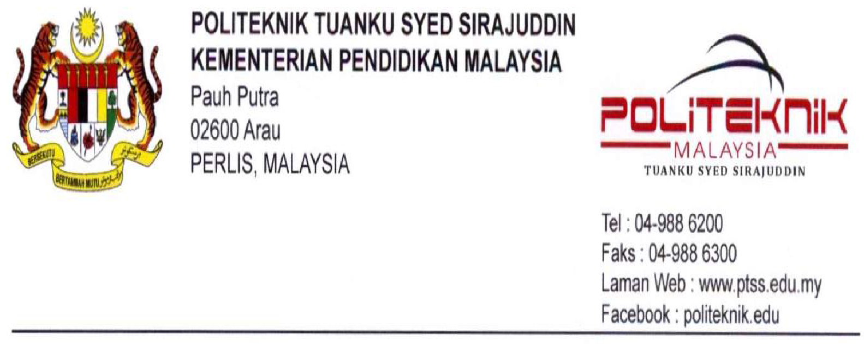

**INSTRUCTION: Please rate each item below to reflect student’s performance.**

|  |  |  |  |  |  |  |  |  |
| --- | --- | --- | --- | --- | --- | --- | --- | --- |
| **NAME** | |  | | **RATING** | | | | |
| **Excellent** | **Good** | **Average** | **Below average** | **Un satisfactory** |
| **REG.NO** | |  | |
| **PROGRAMME** | |  | |
| **No** | **Item** | | **CLO\*** | **5** | **4** | **3** | **2** | **1** |
| A | **TECHNOLOGY LITERACY**  *(Perform hands-on tasks, usage of tools and equipment, adopt a variety of technologies, apply the knowledge gained to perform task, show development in knowledge and skills and/or think creatively and critically)* | | ***1*** |  | | | | |
| B | **EFFECTIVE COMMUNICATION**  *(Ability to acquire and understand information, carry out instructions, analyze linear and non-linear information, show appropriate non-verbal communication, communicate with employees at all levels and/or have basic negotiation skills)* | | ***2*** |  | | | | |
| C | **TEAMWORK**  *(Show positive personality traits, participate actively as a member of the team, carry out tasks in appropriate situations and/or build and maintain good relationships within the team)* | | ***3*** |  | | | | |
| D | **POLICIES, PROCEDURES AND REGULATIONS**  *(Comply with the policies and rules of the organization, job procedures and/or safety and health regulations)* | | ***4*** |  | | | | |
| E | **PROFESSIONAL ETHICS**  *(Report handed-in on time and verified by the supervisor, work independently with minimum supervision, attendance, punctuality and/or solve problems by taking the right action)* | | ***4*** |  | | | | |
| F | **REPORTING**  *(Present ideas and views and/or task reporting (Reflective Journal))* | | ***5*** |  | | | | |
|  | **TOTAL** | | |  | | | | |

*\*CLO = Course Learning Outcome. Kindly refer to Industrial Training Guideline (Industry Partner) for details.*

**Comments/recommendations**

By 18th week of training, student must return the completed form (APPENDIX 1 & 2) to:

**To be completed by Student’s Supervisor**

Name :

Position :

Date :

Signature :

Company/organization stamp:

**UNIT PERHUBUNGAN & LATIHAN INDUSTRI**

Politeknik Tuanku Syed Sirajuddin

Pauh Putra,

02600 Arau,

Perlis.

***fax***

04-9886245

***e-mail***

upli@ptss.edu.my



**INSTRUCTION: Please rate each item below to reflect student’s performance.**

|  |  |  |  |  |  |  |
| --- | --- | --- | --- | --- | --- | --- |
| **NAME** |  | | | | | |
| **REG. NO** |  | | | | | |
| **PROGRAMME** |  | | | | | |
| **CRITERIA** | **CLO\*** | **SCORE** | | | | **MARKS** |
| **4** | **3** | **2** | **1** |
| **Content’s structure**  **a) Daily Activities**  (i)The writing format includes:   * Task * Equipment * Issues /challenges * Solutions * Figures/ Flowchart | 1 | Show extremely good understanding of the task | Show good understanding of the task | Show satisfactory understanding of the task | Lack understanding of the task | [ /4] |
| Relevant use of figure and flowchart | Satisfactory use of figure and flowchart | Adequate use of figure and flowchart | irrelevant use of figure and flowchart | [ /4] |
| Able to identify, analyze problems and recommend effective solutions | Able to identify, analyze problems and recommend good solutions | Able to identify, analyze problems and recommend appropriate solutions | Cannot identify, analyze problems and recommend solutions | [ /4] |
| **Content’s structure**  **a) Daily Activities**  (ii)Work Process | 4 | Develop and organize work process well and creatively | Develop and organize work process well | Develop and organize work process satisfactorily | Develop and organize work process unsatisfactorily | [ /4] |
| **Content’s structure**  **b) Reflection** | 5 | Relevant response to the task | Satisfactory response to the task | Adequate response to the task | irrelevant responses to the task | [ /4] |
| **Language** | 5 | Meaning is very clear. | Meaning comes across clearly. | Meaning may be occasionally unclear but not incomprehensible. | Meaning is often unclear and incomprehensible. | [ /4] |
| Very appropriate and varied terminology. | Reasonably appropriate and varied terminology. | Modestly appropriate terminology but these are mainly simple. | Inappropriate terminology and no variety. | [ /4] |
| **Verification/Checking/ Monitoring** | 4 | Verified by the supervisor and  report always handed in  on time | Verified by the supervisor and  report seldom handed in  on time | Verified by the supervisor and  report rarely handed in  on time | Verified by the supervisor and  report never handed in on time | [ /4] |
| *\*CLO = Course Learning Outcome. Kindly refer to Industrial Training Guideline (Industry Partner) for details.*  **Fulfill by student supervisor**  Name :  Position :  Date :  Signature :  Company/organization stamp:  **By fax to**  04 – 917 4232  04 – 914 6132  *or*  **By email to**  upli@polimas.edu.my  **By mail to**  **UNIT PERHUBUNGAN & LATIHAN INDUSTRI**  Politeknik Sultan Abdul Halim Muadzam Shah  Bandar Darulaman 06000 JITRA KEDAH  Kindly return to us the complete form **(APENDIX 1 & 2)** by mail/fax/email by using below information as showed. This form can be completed during week-20 of student training  By 18th week of training, student must return the completed form (APPENDIX 1 & 2) to: | | | | | **Total Marks** | **[ /32]** |

**To be completed by Student’s Supervisor**

Name :

Position :

Date :

Signature :

Company/organization stamp:

**To be filled in by Student’s Supervisor**

Name :

Position :

Date :

Signature :

Company/organization stamp:

**Fax**

04-9886245

***e-mail***

upli@ptss.edu.my

**UNIT PERHUBUNGAN & LATIHAN INDUSTRI**

Politeknik Tuanku Syed Sirajuddin

Pauh Putra,

02600 Arau,

Perlis.



**INSTRUCTION: Please rate each item below to reflect student’s performance.**

|  |  |  |  |  |  |  |  |  |
| --- | --- | --- | --- | --- | --- | --- | --- | --- |
| **NAME** | |  | | **RATING** | | | | |
| **Excellent** | **Good** | **Average** | **Below average** | **Unsatisfactory** |
| **REG. NO** | |  | |
| **PROGRAMME** | |  | |
| **No** | **Item** | | **CLO** | **5** | **4** | **3** | **2** | **1** |
| A | **EFFECTIVE COMMUNICATION** | | **2** |  |  |  |  |  |
| 1 | Access information in the form of verbal and written communication | |  |  |  |  |  |  |
| 2 | Show appropriate non-verbal communication | |  |  |  |  |  |  |
| B | **POLICIES, PROCEDURES AND REGULATIONS** | | **4** |  |  |  |  |  |
| 1 | Comply with the rules of the organization | |  |  |  |  |  |  |
| 2 | Understand the job procedures | |  |  |  |  |  |  |
| 3 | Health and safety awareness | |  |  |  |  |  |  |
| C | **PROFESSIONAL ETHICS** | | **4** |  |  |  |  |  |
| 1 | Report handed-in on time and Verified by the supervisor | |  |  |  |  |  |  |
| 2 | Perform task in various situations | |  |  |  |  |  |  |
| 3 | Responsible behavior | |  |  |  |  |  |  |
| 4 | Accountability and integrity | |  |  |  |  |  |  |
| 5 | Ethics and protocols | |  |  |  |  |  |  |
| 6 | Time management | |  |  |  |  |  |  |
| 7 | Awareness of current issues | |  |  |  |  |  |  |
| D | **REPORTING** | | **5** |  |  |  |  |  |
| 1 | The reflective journal report is written accordingly to the undertaken activities | |  |  |  |  |  |  |
| 2 | The reflective journal is updated daily | |  |  |  |  |  |  |
| 3 | The Reflective journal is written clearly and neatly | |  |  |  |  |  |  |
|  | Total Score | | |  |  |  |  |  |

/75

Grand total:

|  |
| --- |
| **Lecturer’s comment:** |

**Company/organization stamp:**

LECTURER’S NAME :

POSITION :

DATE OF OBSERVATION :

STAMP :

